

ME5406 Deep Learning for Robotics

AY2025/26 Semester 2

Project 1 Report

A0271815A

Lock De Ying Ethan

1. Results: 4×4 Map
Figures 1–7 correspond to the results obtained for the 4×4 Frozen Lake environment.

1.1 Monte Carlo (Figures 1–2)
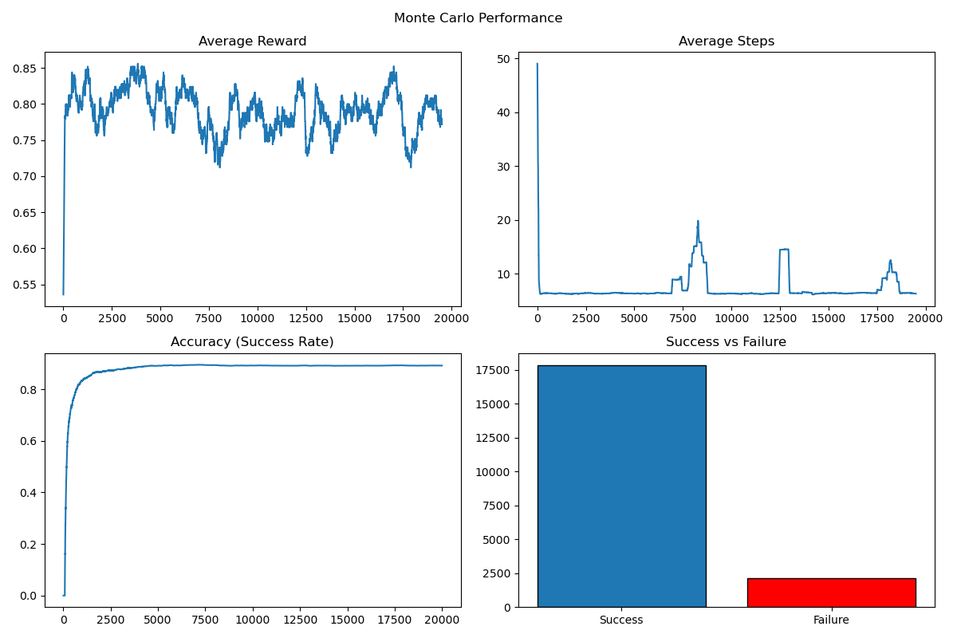
Figure 1: Performance metrics of Monte Carlo control on the 4×4 environment: average reward per episode, average number of steps per episode, success rate, and success versus failure over training.
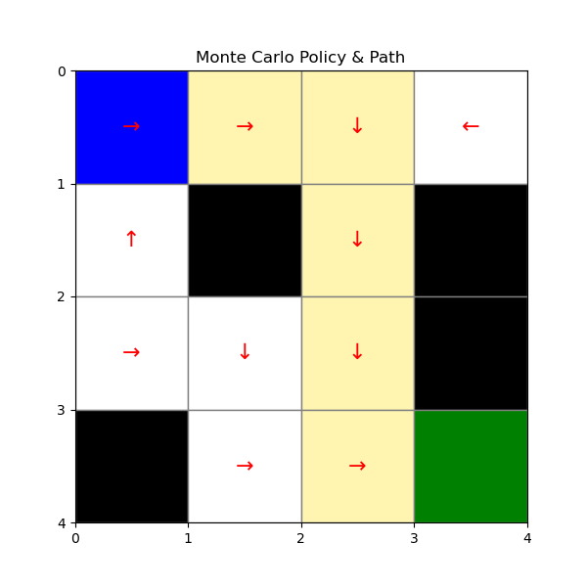
Figure 2: Final learned policy obtained using Monte Carlo control on the 4×4 grid. Arrows indicate the greedy action selected at each state, with holes shown in black and the goal state in green.
Figure 1 presents the performance metrics of the Monte Carlo control algorithm, including the average reward per episode, average number of steps per episode, accuracy (success rate), and success versus failure statistics. Figure 2 illustrates the final learned policy.
From Figure 1, the accuracy converges to approximately 0.89 after sufficient training episodes. The average reward stabilizes near 0.8, indicating that the agent successfully reaches the goal in most episodes while occasionally falling into holes. The average number of steps converges to approximately 6–7 steps, which corresponds to a near-optimal path length in the 4×4 grid. However, noticeable spikes in the step plot are observed during the early stages of training. These fluctuations indicate higher variance in the initial episodes, which is characteristic of Monte Carlo methods due to their reliance on complete episode returns.
The learned policy shown in Figure 2 demonstrates a valid and near-optimal path from the start state to the goal state. The agent successfully learns to avoid holes and move efficiently toward the target.

1.2 SARSA (Figures 3–4)
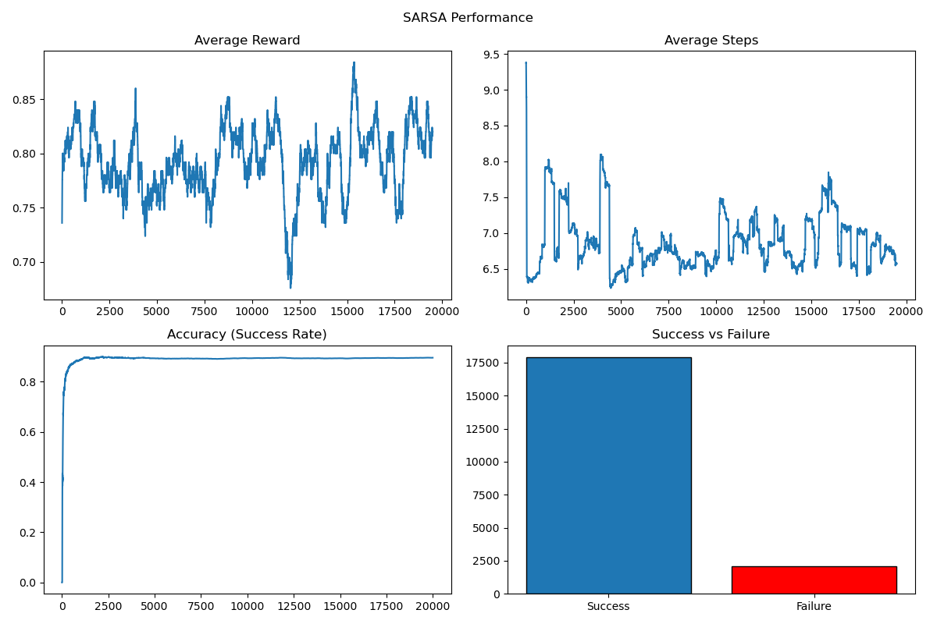
Figure 3: Performance metrics of SARSA with ε-greedy behaviour policy on the 4×4 Frozen Lake environment, including average reward, average steps, accuracy, and success versus failure counts.
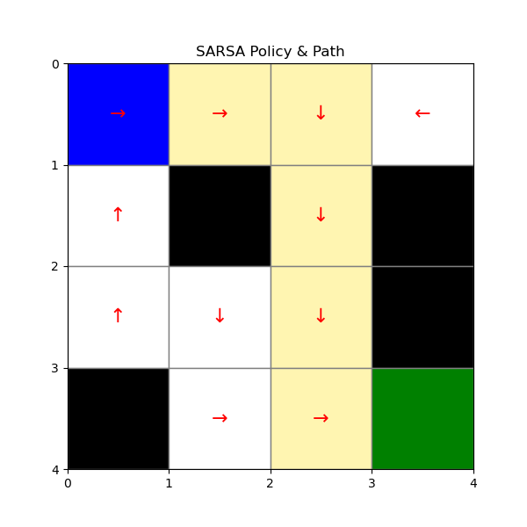
Figure 4: Final learned policy obtained using SARSA on the 4×4 grid. The policy demonstrates a near-optimal path from the start state to the goal while avoiding hole states.

Figure 3 shows the performance metrics of the SARSA algorithm, while Figure 4 illustrates the learned policy.
The accuracy for SARSA converges to approximately 0.9, which is comparable to Monte Carlo performance in the 4×4 grid. The convergence appears slightly smoother than Monte Carlo in terms of average reward and step count. Although minor oscillations are visible in the reward and step plots, these fluctuations are expected due to the ε-greedy exploration policy used during learning.
The learned policy in Figure 4 closely resembles that of the Monte Carlo algorithm. The agent identifies an efficient path to the goal while successfully avoiding hole states. The similarity between the SARSA and Monte Carlo policies indicates that in small state spaces with short trajectories, both algorithms can reliably learn near-optimal behaviour.

1.3 Q-learning (Figures 5–6)
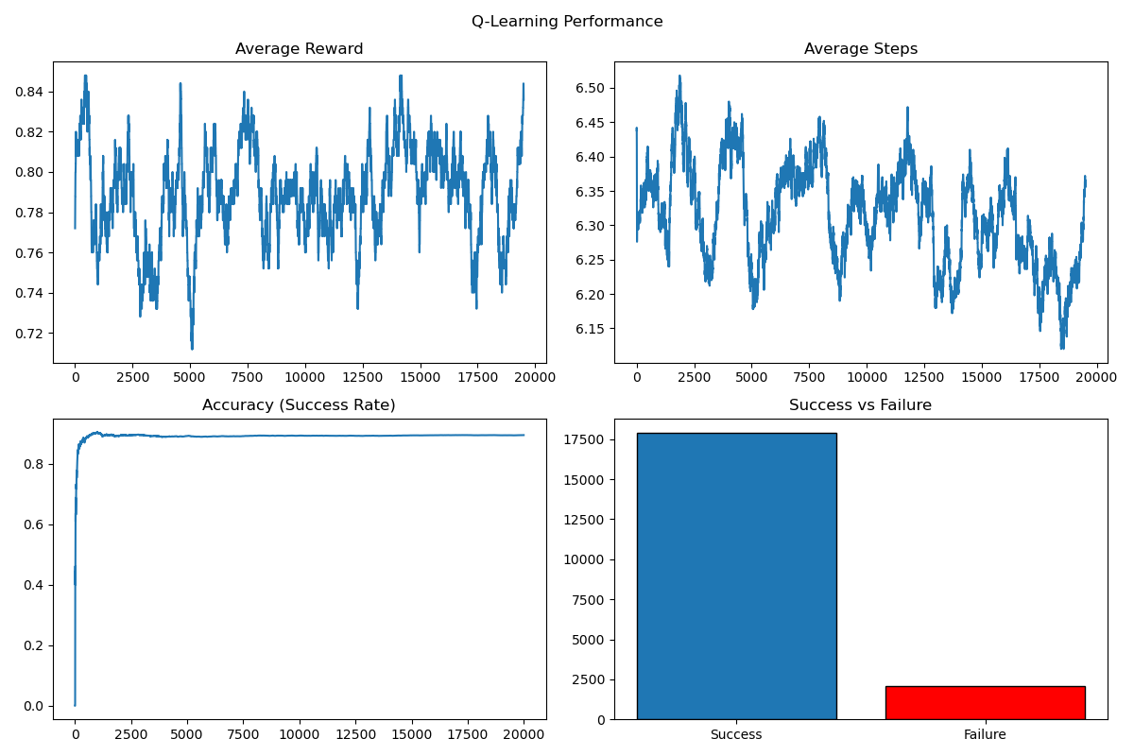
Figure 5: Performance metrics of Q-learning with ε-greedy behaviour policy on the 4×4 Frozen Lake environment, illustrating convergence behaviour in terms of reward, steps, accuracy, and episode outcomes.
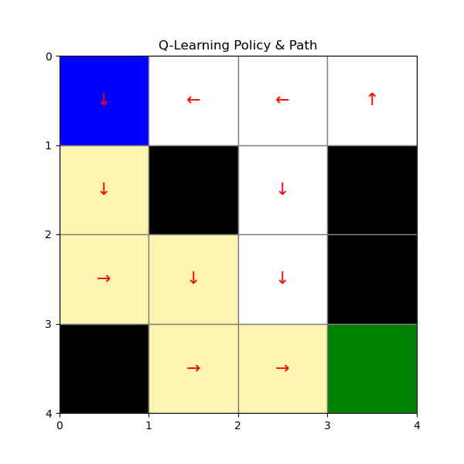
Figure 6: Final learned policy obtained using Q-learning on the 4×4 grid. The arrows represent the greedy action at each state after convergence.
Figure 5 presents the performance metrics for the Q-learning algorithm, and Figure 6 displays the final learned policy.
Among the three methods, Q-learning exhibits the fastest convergence. The reward curve stabilizes quickly and demonstrates the most consistent behaviour across training episodes. The accuracy reaches approximately 0.9, comparable to the other methods. Additionally, the average number of steps converges smoothly to approximately 6–7 steps, indicating efficient navigation.
The learned policy in Figure 6 appears slightly more aggressive in directing the agent along the shortest path toward the goal. This behaviour is consistent with the off-policy nature of Q-learning, which updates action values based on the greedy action estimate.

1.4 Algorithm Comparison (Figure 7)
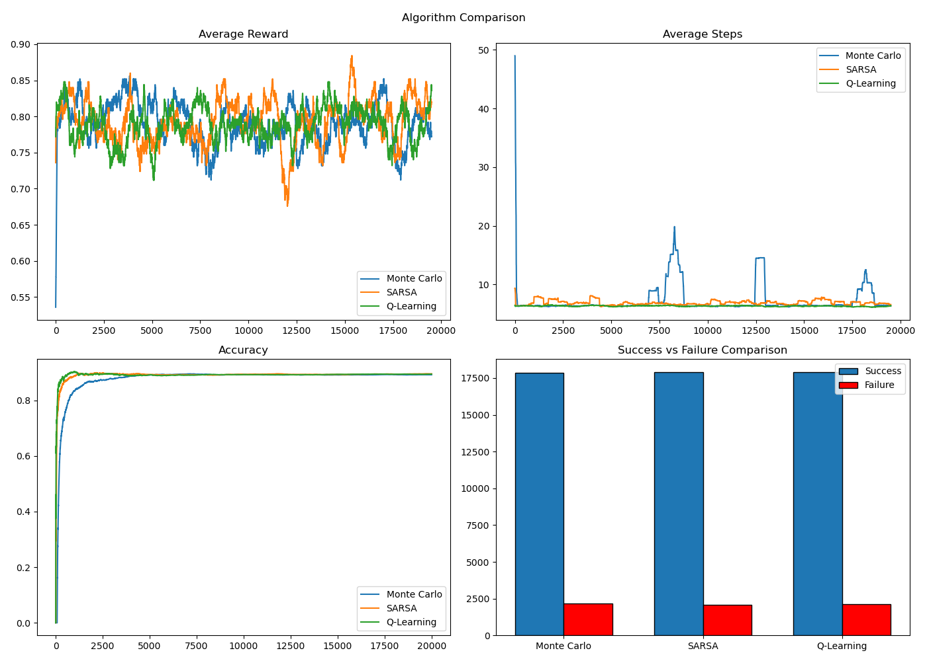
Figure 7: Comparison of Monte Carlo, SARSA, and Q-learning performance on the 4×4 environment, showing overlayed curves for average reward, average steps, accuracy, and success versus failure statistics.
Figure 7 overlays the performance curves of all three algorithms for direct comparison. The average reward, step count, accuracy, and success statistics demonstrate that all three methods achieve similar final performance in the 4×4 grid.
Q-learning converges marginally faster than SARSA and Monte Carlo. Monte Carlo exhibits the highest early variance, particularly in the step count plot. However, these differences are relatively minor due to the small state space and short episode lengths. Overall, in the 4×4 environment, all three algorithms are capable of learning near-optimal policies.

2. Results: 10×10 Map
Figures 8–14 correspond to the results obtained for the 10×10 Frozen Lake environment with 25%-hole distribution.

2.1 Monte Carlo (Figures 8–9)
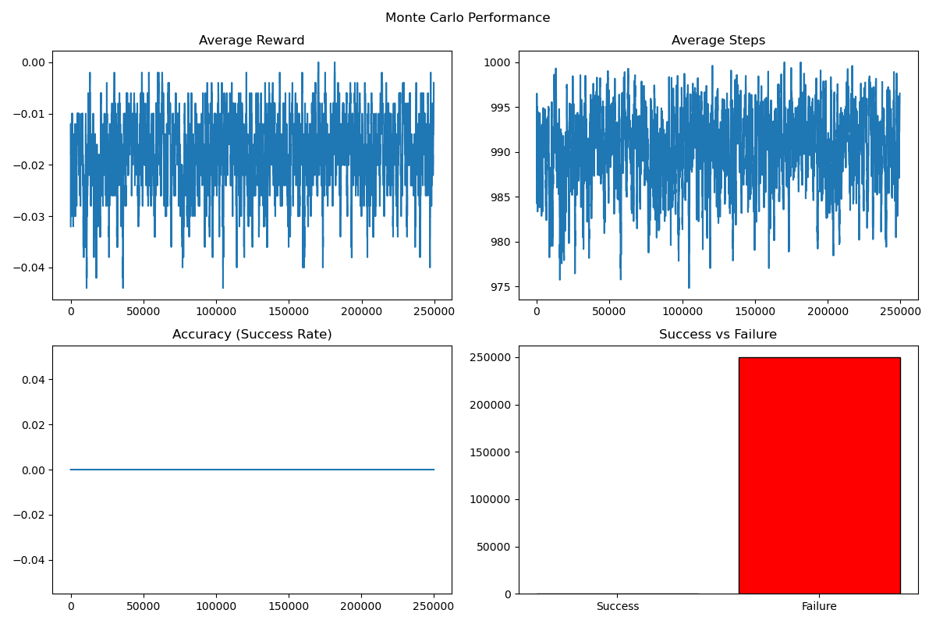
Figure 8: Performance metrics of Monte Carlo control on the 10×10 environment, showing average reward, average steps, accuracy, and success versus failure over training episodes.
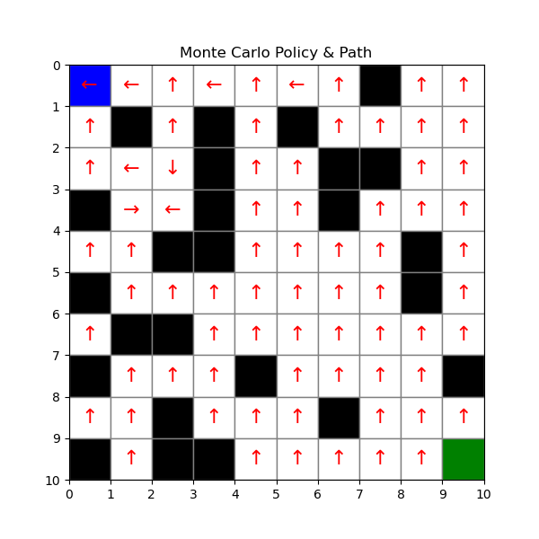
Figure 9: Final learned policy obtained using Monte Carlo control on the 10×10 grid. Absence of a coherent path reflects the algorithm’s failure to learn a successful policy in the larger state space.
Figure 8 shows the performance metrics of Monte Carlo control in the 10×10 environment, and Figure 9 displays the resulting policy.
In contrast to the 4×4 results, the accuracy remains at 0% throughout training. The average reward remains near zero, and the average number of steps remains close to the maximum allowed episode length. The success-versus-failure plot confirms that all episodes terminate in failure.
The learned policy shown in Figure 9 does not form a coherent path to the goal. Instead, the actions appear inconsistent and fail to guide the agent successfully across the grid. These results indicate that Monte Carlo control fails to scale effectively to the larger state space.

2.2 SARSA (Figures 10–11)
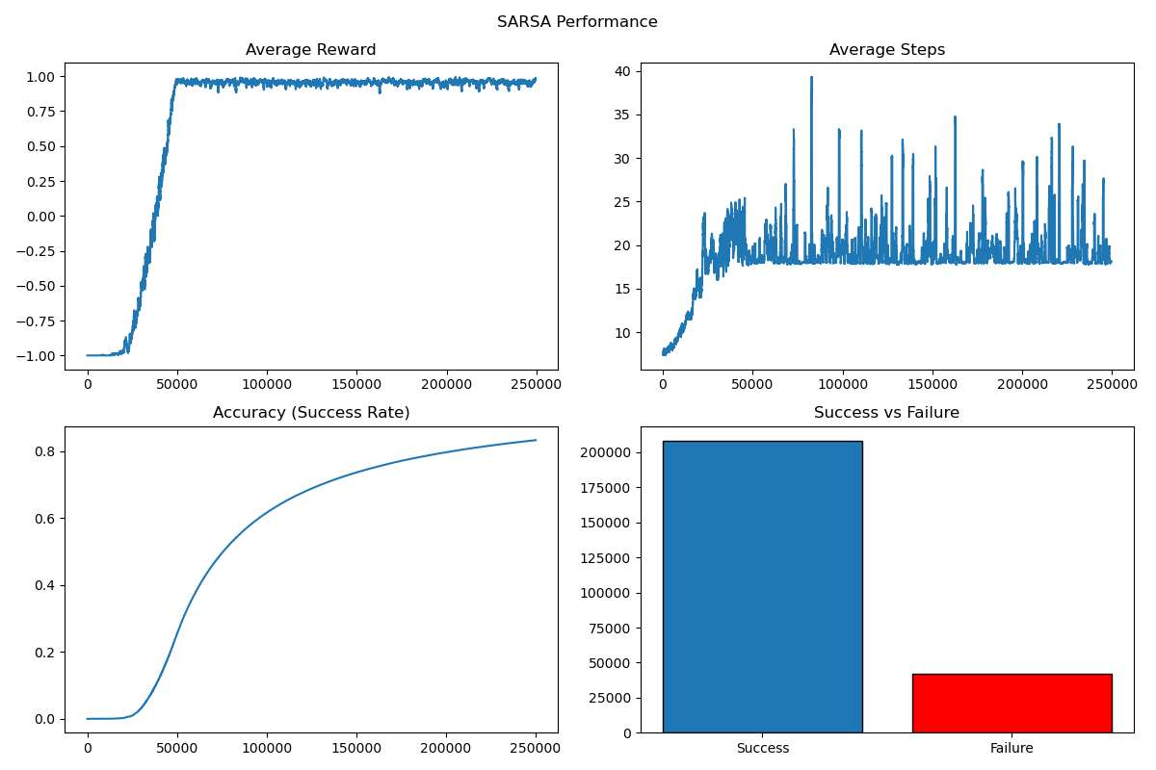
Figure 10: Performance metrics of SARSA with ε decay on the 10×10 Frozen Lake environment, illustrating convergence in reward, step count, success rate, and episode outcomes.
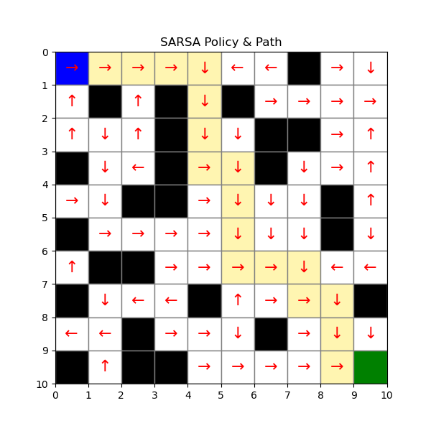
Figure 11: Final learned policy obtained using SARSA on the 10×10 grid. The arrows indicate the learned greedy actions forming a valid path to the goal.
Figure 10 presents the performance metrics of the SARSA algorithm after introducing ε decay, while Figure 11 illustrates the learned policy.
After incorporating ε decay, the accuracy improves significantly and converges to approximately 83%. The average reward converges toward +1, indicating frequent successful episodes. The average number of steps stabilizes around 18–20, which is reasonable given the larger grid size.
The learned policy in Figure 11 forms a clear and valid path to the goal while avoiding holes. Compared to Q-learning, the SARSA policy appears slightly more conservative, reflecting its on-policy update mechanism. Nevertheless, the algorithm successfully learns effective behavior in the larger environment after appropriate hyperparameter tuning.

4.3 Q-learning (Figures 12–13)
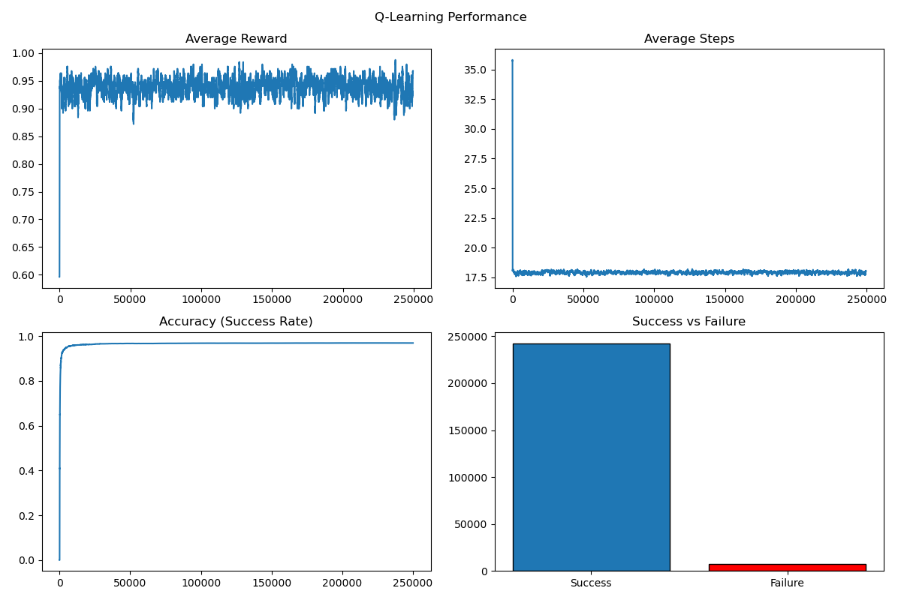
Figure 12: Performance metrics of Q-learning with ε decay on the 10×10 Frozen Lake environment, demonstrating stable convergence and high success rate.
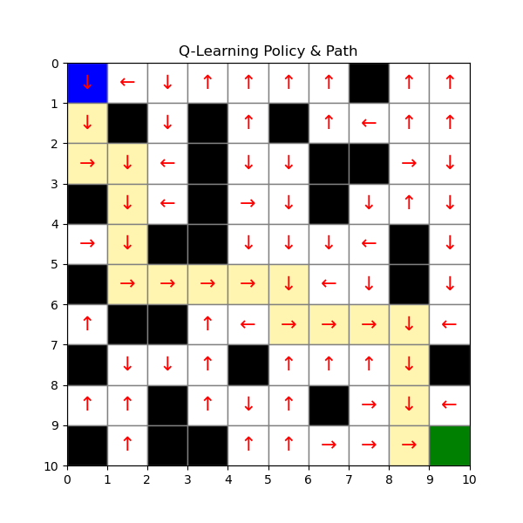
Figure 13: Final learned policy obtained using Q-learning on the 10×10 grid. The policy closely approximates a shortest-path solution while successfully avoiding hole states.
Figure 12 displays the performance metrics of Q-learning in the 10×10 grid, and Figure 13 shows the final policy.
Q-learning achieves approximately 97% accuracy, which is the highest among the three algorithms. The reward curve converges rapidly and remains highly stable. The average number of steps stabilizes around 17–18 steps, slightly lower than SARSA, indicating a more efficient path.
The learned policy in Figure 13 closely resembles a shortest-path solution from the start to the goal. Failures are minimal, and convergence is both fast and stable. These results demonstrate the strong scalability of Q-learning in larger state spaces.

2.4 Algorithm Comparison (Figure 14)
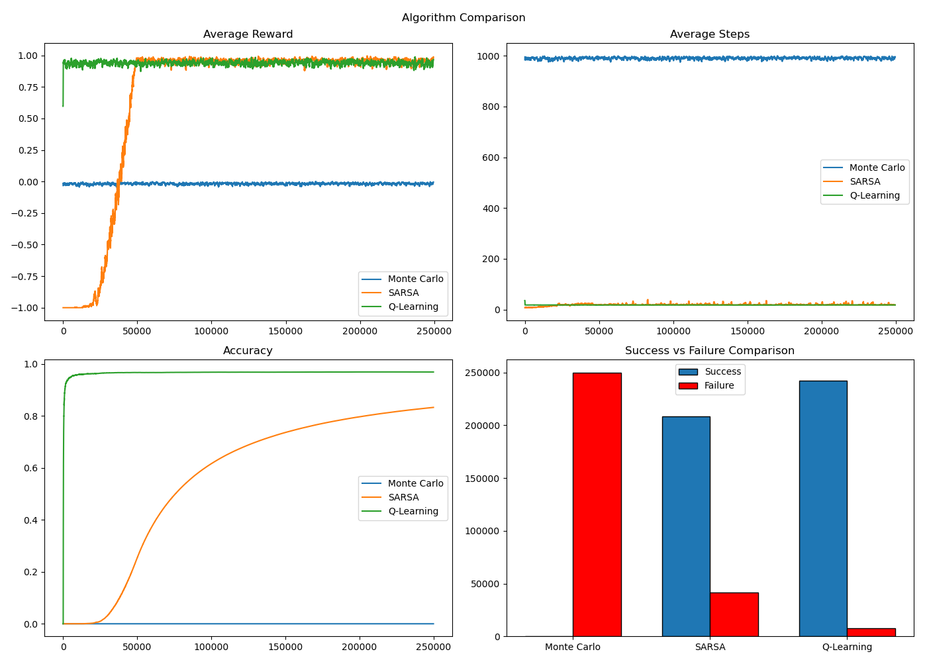
Figure 14: Comparison of Monte Carlo, SARSA, and Q-learning performance on the 10×10 environment, highlighting differences in convergence behaviour, stability, and final accuracy across algorithms.
Figure 14 provides a direct comparison of the three algorithms in the 10×10 environment. The divergence in performance is clearly visible. Monte Carlo fails entirely, with zero successful episodes. SARSA converges steadily after tuning and achieves strong performance. Q-learning dominates in terms of accuracy, stability, and convergence speed.

3. Comparative Analysis

3.1 Similarities
In the 4×4 environment, all three algorithms converge successfully and achieve high accuracy. The learned policies are nearly identical and correspond to efficient paths to the goal. This similarity arises because the small state space and short trajectories allow reward information to propagate quickly. Return variance remains manageable, and even Monte Carlo methods can perform effectively under these conditions.

3.2 Differences
In the 10×10 environment, significant differences emerge. Monte Carlo fails to learn any successful policy. SARSA achieves moderate to strong performance after tuning, while Q-learning performs best overall.
These differences can be explained by the structural properties of the algorithms. Monte Carlo methods lack bootstrapping and rely solely on complete episode returns, making them inefficient in long-horizon, sparse-reward environments. SARSA, being on policy, is sensitive to exploration scheduling and requires careful tuning of ε decay. Q-learning, as an off-policy method, updates toward the greedy action estimate and therefore propagates reward information more efficiently.

4. Unexpected Outcomes

4.1 Monte Carlo Failure
The complete failure of Monte Carlo in the 10×10 grid was an unexpected outcome. This collapse can be attributed to high return variance, sparse reward signals, longer episode lengths, and delayed updates. Since most episodes end in failure before reaching the goal, positive returns are rare and insufficient to drive meaningful learning.

5. Difficulties Encountered
Several challenges were encountered during the implementation and experimentation process. These included high variance in the larger grid, balancing exploration and exploitation, correctly implementing first-visit tracking in Monte Carlo, and sensitivity to hyperparameter choices.
These issues were addressed through systematic hyperparameter tuning, implementation of ε decay scheduling, reduction of learning rate where necessary, and restructuring of code to ensure correct state-action tracking and updates.

6. Significant Implementation Issues

6.1 Importance of Bootstrapping
The experiments clearly demonstrate the importance of bootstrapping. Temporal-difference methods (SARSA and Q-learning) significantly outperform Monte Carlo in larger state spaces due to their ability to propagate value estimates incrementally rather than waiting until episode termination.

6.2 Scalability
As the state space increases, the limitations of non-bootstrapped methods become more pronounced. The growth in trajectory length and sparse reward distribution disproportionately affects Monte Carlo methods, highlighting scalability challenges in reinforcement learning.

7. Conclusions
In small environments such as the 4×4 grid, all three algorithms perform similarly and converge to near-optimal policies. However, in larger environments such as the 10×10 grid, substantial differences emerge. Monte Carlo fails to scale effectively, SARSA performs well after careful tuning, and Q-learning demonstrates the best overall performance.
Overall, Q-learning exhibits superior scalability, stability, and convergence speed among the three tabular reinforcement learning methods implemented in this project.

